Maryland Honey Harvest Festival.
Patuxent Research Refuge National Wildlife Visitor Center, Laurel, MD.
September 17, 2011.

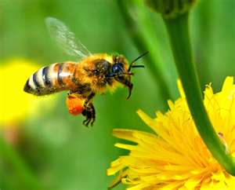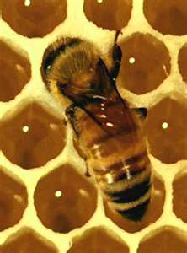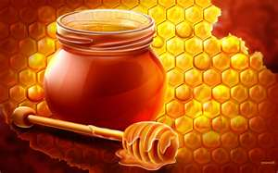

Honey & Bees in the Qur’an.
"And your Lord taught the honey bee to build its cells in hills, on trees, and in (men's) habitations; Then to eat of all the produce (of the earth), and find with skill the spacious paths of its Lord: there issues from within their bodies a drink of varying colors, wherein is healing for men: verily in this is a Sign for those who give thought. (Surah An-Nahl, 68-69)

Honey Bee in the Hadith.
On the authority of Abdullah ibn ‘Amr, the Prophet said "By Allah in Whose hand is my soul, The believer is like a bee that eats what is wholesome and produces what is wholesome. And when it lands on a (small) branch, it doesn't break it."
Vocabulary
Honey Bee- An-Nahl
Honey- Asal
Bee Crafts

Bug Antenna

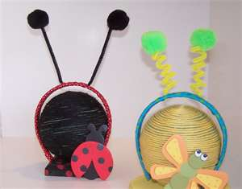
-Supplies
-plastic headband (find inexpensive ones at dollar stores)
-2 chenille stems
-craft glue
-2 craft foam circles or pompom
-Art supplies such as markers and glitter
Directions:
-Let kids decorate two craft foam circles using markers, glitter and other art supplies.
-Glue the circles onto one end of each chenille stem.
-Wrap the other end of the chenille stem around the headband at the top. Leave approximately two inches between the chenille stems. If needed, add a dot of glue to hold the stems in place.

-Bumblebee Maze bookmark (DTLK Kids).

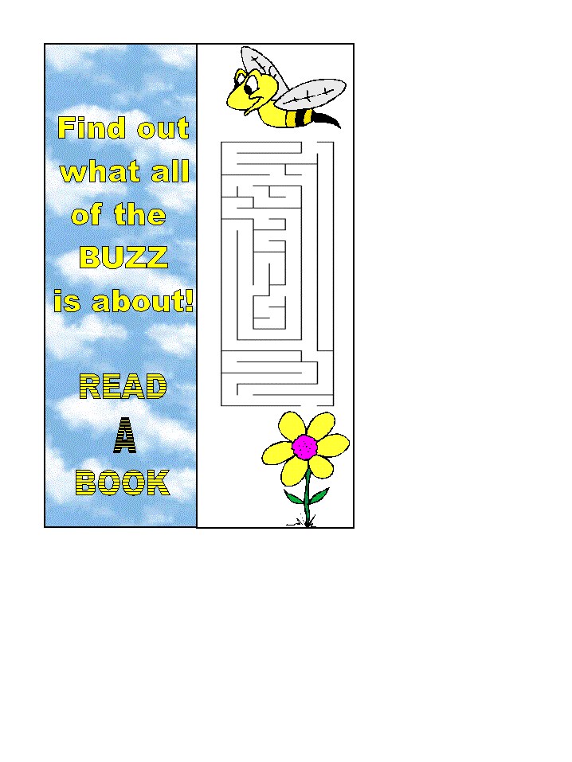
Print these "home-made" bookmarks for a special reading companion.
To add that extra bit of motivation, print out a bookmark for your child, your friend or yourself as a reward for reading a certain number of stories. Even if you have a color printer, you may prefer the black and white version which the kids can color in themselves...

Materials
- paper
- printer
- scissors
- glue
- crayons or something else to color with (for b&w print version)

- Optional:
  - wool
  - clear contact paper

Instructions
- Click on the link of your choice (below) to print the template. Color as appropriate.
- Cut the bookmark out (one big rectangle) and fold in half (left to right) along the center line.
- Glue so it stays folded together.
- Optional: cover with clear contact paper so it lasts longer (you could also put a piece of cardboard in the center before gluing for a sturdier bookmark)
- Optional: Poke a hole in the top of the bookmark and tie a string/wool through as a tassel.
Color: http://www.dltk-kids.com/crafts/insects/images/cbeemazebookmark.gif
B/W: http://www.dltk-kids.com/crafts/insects/images/bbeemazebookmark.gif

